---------------------------------------------------------------------

-- LAB 09

--

-- Exercise 3

---------------------------------------------------------------------

USE TSQL;

GO

---------------------------------------------------------------------

-- Task 1

--

-- A junior analyst prepared a T-SQL statement to retrieve the number of orders and the number of customers for each order year. Observe the provided T-SQL statement and execute it:

--

-- Observe the result and notice that the number of orders is the same as the number of customers. Why?

--

-- Correct the T-SQL statement to show the correct number of customers that placed an order for each year.

--

-- Execute the written statement and compare the results that you got with the recommended result shown in the file 72 - Lab Exercise 3 - Task 1 Result.txt.

---------------------------------------------------------------------

SELECT

YEAR(orderdate) AS orderyear,

COUNT(orderid) AS nooforders,

COUNT(custid) AS noofcustomers

FROM Sales.Orders

GROUP BY YEAR(orderdate);

---------------------------------------------------------------------

-- Detyra 1

--

-- Nje analist fillestar pergatiti veprimet T-SQL per te nxjerre numrin e porosive dhe

-- numrin e klienteve per cdo order year.Observo veprimet T-SQL dhe ekzekutojini ato:

-- Observoni rezultatin dhe vini re qe numri i porosive eshte i njejte me numrin e klienteve. Pse?

-- Korrigjoni veprimet T-SQL per te treguar numrin e sakte te klienteve qe kryejne porosi per cdo vit.

-- Ekzekutoni veprimet e mesiperme dhe krahasoni rezultatet qe ju moret me rezultatet e deshiruara te treguara ne dokumentin 72 - Lab Exercise 3 - Task 1 Result.txt.

---------------------------------------------------------------------

SELECT

YEAR(orderdate) AS orderyear,

COUNT(orderid) AS nooforders,

COUNT(custid) AS noofcustomers

FROM Sales.Orders

GROUP BY YEAR(orderdate)

ORDER BY YEAR(orderdate);

--Query është ekzekutuar me sukses.Konkretisht si më poshtë:

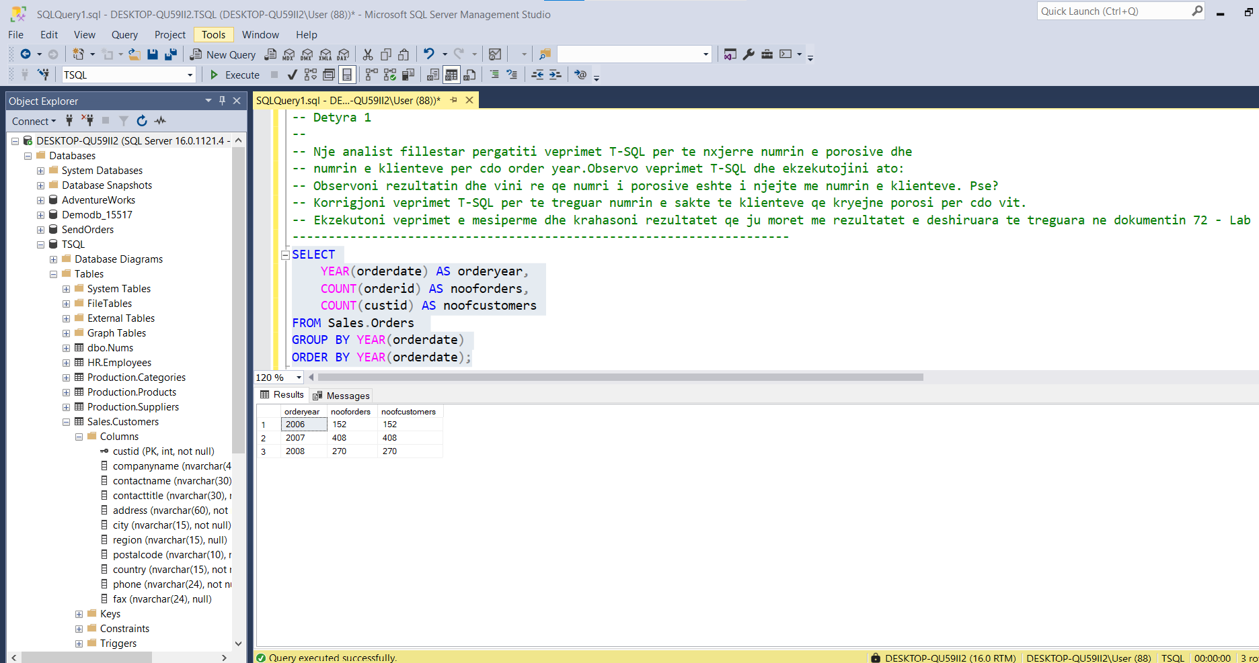

---------------------------------------------------------------------

-- Task 2

--

-- Write a SELECT statement to retrieve the number of customers based on the first letter of the values

-- in the contactname column from the Sales.Customers table. Add an additional column to show the

-- total number of orders placed by each group of customers. Use the aliases firstletter, noofcustomers and nooforders.

-- Order the result by the firstletter column.

-- Execute the written statement and compare the results that you got with the recommended result shown in the file 73 - Lab Exercise 3 - Task 2 Result.txt.

---------------------------------------------------------------------

---------------------------------------------------------------------

-- Detyra 2

--

-- Nxirrni 'numrin e klienteve' bazuar ne shkronjen e pare te vleres ne kolonen contactname nga tabela Sales.Customers.

-- Shto nje kolone shtese per te treguar numrin total te porosive qe kane ndodhur nga cdo grup i klienteve.

-- Perdor si aliases firstletter, noofcustomers dhe nooforders. Rendit rezultatin sipas kolones firstletter.

-- Ekzekutoni veprimet e mesiperme dhe krahasoni rezultatet qe ju moret me rezultatet e deshiruara te treguara

-- ne dokumentin 73 - Lab Exercise 3 - Task 2 Result.txt.

---------------------------------------------------------------------

Select SUBSTRING(c.contactname,1,1) as firstLetter , count(Distinct c.custid) as noofcustomers , count(o.orderid) as nooforders

From Sales.Customers as c Inner Join Sales.Orders as o ON c.custid = o.custid

Group by SUBSTRING(c.contactname,1,1)

--

Select \* From Sales.Customers c inner join Sales.Orders o ON c.custid = o.custid

Order By c.contactname asc

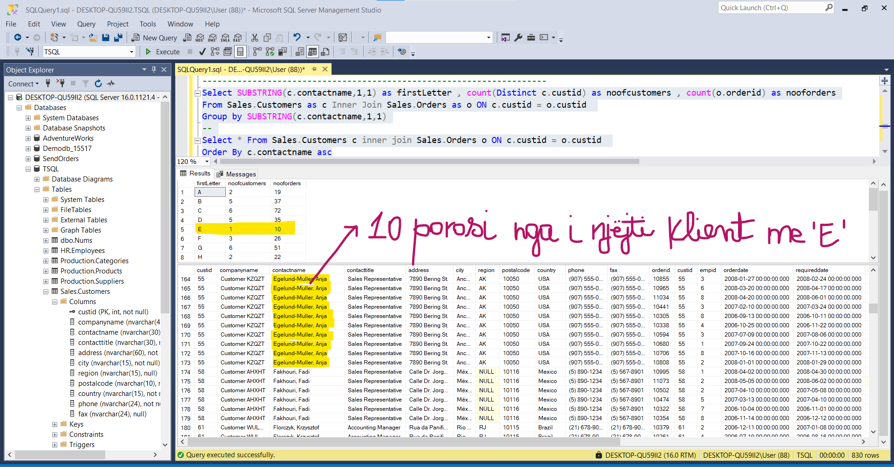

---------------------------------------------------------------------

-- Task 3

--

-- Copy the T-SQL statement in exercise 1, task 4, and modify to include the following information about

-- for each product category: total sales amount, number of orders, and average sales amount per order.

-- Use the aliases totalsalesamount, nooforders, and avgsalesamountperorder, respectively.

-- Execute the written statement and compare the results that you got with the recommended

-- result shown in the file 74 - Lab Exercise 3 - Task 3 Result.txt.

------------------------------------------------------------------

---------------------------------------------------------------------

-- Detyra 3

-- Kopjoni veprimet T-SQL ne ushtrimin 1, detyra 4, dhe modifikojeni per te perfshire informacionin

-- qe vijon rreth cdo product category: total sales amount , number of orders dhe average sales amount per order.

-- Perdor alias totalsalesamount, nooforders, dhe avgsalesamountperorder.

-- Ekzekutoni veprimet e mesiperme dhe krahasoni rezultatet qe ju moret me rezultatet e deshiruara

-- te treguara ne dokumentin 74 - Lab Exercise 3 - Task 3 Result.txt.

---------------------------------------------------------------------

Select c.custid, c.city, c.contactname,count(o.orderid) as nooforders,DATEPART(year,o.orderdate) as orderyear,

SUM((od.unitprice \* od.qty)\*(1- od.discount)) as totalsalesamount ,

AVG((od.unitprice \* od.qty)\*(1- od.discount)) AS avgsalesamountperorder

From Sales.Orders o INNER JOIN Sales.Customers c On c.custid = o.custid

INNER JOIN HR.Employees e ON o.empid = e.empid INNER JOIN Sales.OrderDetails od ON o.orderid = od.orderid

Where od.productid IN(

Select p.productid

From Sales.OrderDetails od INNER JOIN

Production.Products p ON od.productid =

p.productid

INNER JOIN Production.Categories pc ON

p.categoryid = pc.categoryid

)

group by c.custid,c.contactname,c.city,DATEPART(year,o.orderdate)

Having(count(o.orderid))=5

Order by orderyear

